



**Disclaimer: The content is curated from online/offline resources and used for educational purpose only**

**LAB MANUAL**

**Unit VI – Image Processing**

**Unit VI – Image Processing**

**Lab 2. Waste Sorting Using Teachable machine**

**Objective**

The objective of this project is to create an automated waste sorting system using Teachable Machine to classify various waste materials. The system should be able to distinguish between different categories of waste and provide accurate classification results to support waste management and recycling efforts.

**Problem**

The world is facing an escalating waste management crisis, with improper waste sorting being one of the primary contributors to environmental degradation. Sorting waste materials into categories such as plastics, metals, organic waste, and paper is crucial for recycling and minimizing landfill waste. However, manual sorting processes are often time-consuming, error-prone, and labor-intensive, leading to inefficient recycling systems.

The problem lies in the inability of most waste management systems to automatically and accurately sort a wide variety of waste types efficiently. The increasing volume and variety of waste materials make it challenging for traditional sorting methods to handle diverse waste streams. There is a need for an automated solution that can correctly classify different types of waste materials based on their physical properties, such as texture, color, and shape.

**Solution**

1. Open Teachable Machine:
   1. Go to Teachable Machine.
   2. Choose the Image Project option and then Standard Image Model.
2. Set Up Classes:
   1. By default, Teachable Machine gives you a class labeled “Class 1.” Rename it to “fire.”
   2. Click Add a Class for each waste type, and rename them as “nofire”
3. Upload Images:
   1. For each class, upload your prepared images.
   2. Make sure each waste type has enough examples for the model to learn distinct features. The more images, the better the model’s performance.
4. Train the Model:
   1. Once images are uploaded and categorized, click on the Train Model button.
   2. Teachable Machine will process the images, building a model that recognizes patterns in each category.
5. Testing the Model:
   1. After training, test the model by uploading or using the webcam to capture new images of each waste type.
   2. The model will display predictions, showing the likelihood that an image belongs to each category.
6. Export Model

**Procedures**

**Training the Model with Teachable Machine**

1. **Open Teachable Machine**:
   * Go to Teachable Machine. (https://teachablemachine.withgoogle.com/) ￼
   * Choose the **Image Project** option and then **Standard Image Model**.

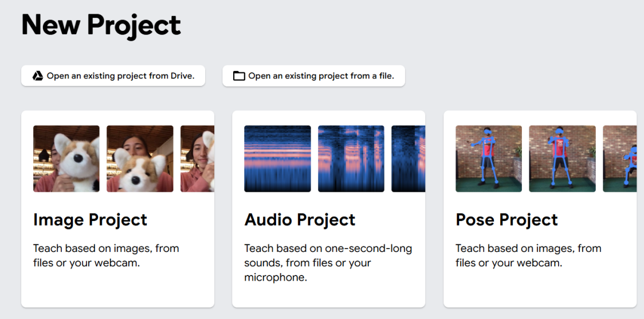

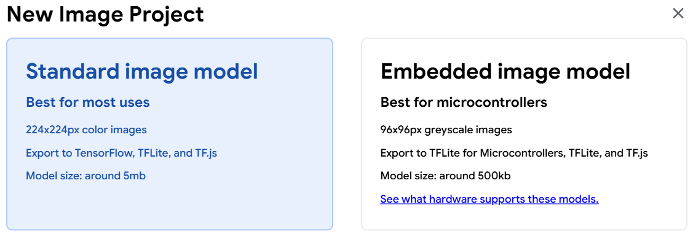

1. **Set Up Classes**:
   * By default, Teachable Machine gives you a class labeled “Class 1.” Rename it to “food_waste”
   * Click **Add a Class** for each waste type, and rename them as “,leaf_waste, and paper_waste”

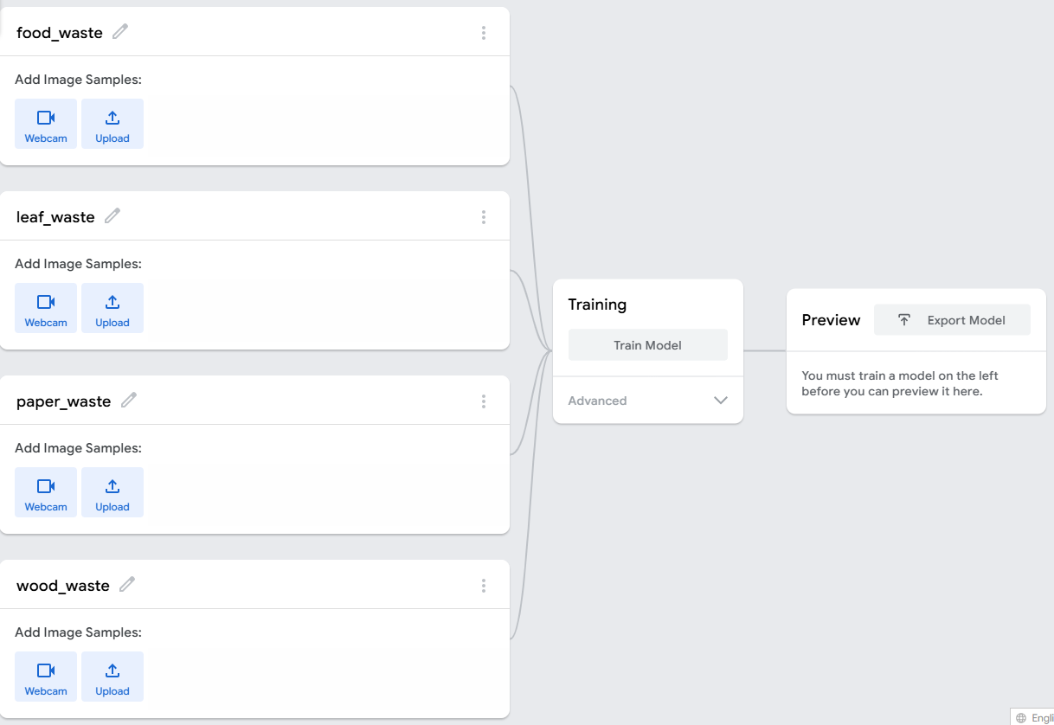

1. **Upload Images**:
   * For each class, upload your prepared images.
   * Make sure each waste type has enough examples for the model to learn distinct features. The more images, the better the model’s performance.

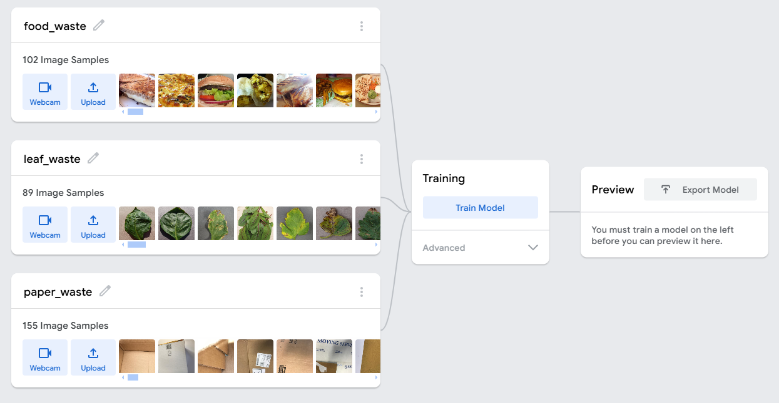

1. **Train the Model**:
   * Once images are uploaded and categorized, click on the **Train Model** button.

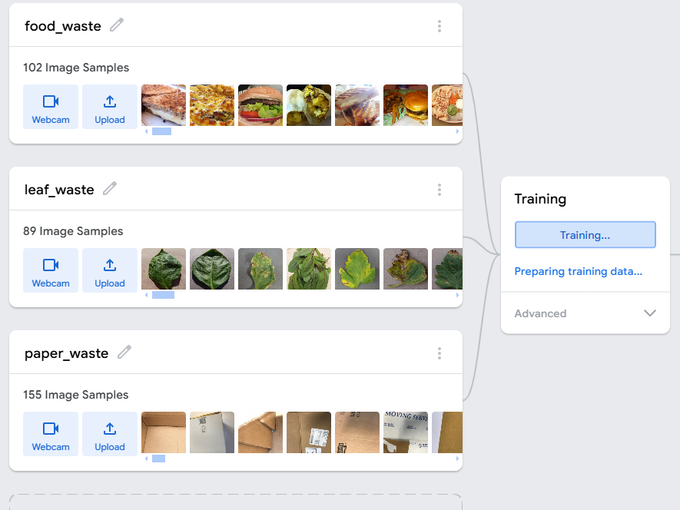

* + Teachable Machine will process the images, building a model that recognizes patterns in each category.

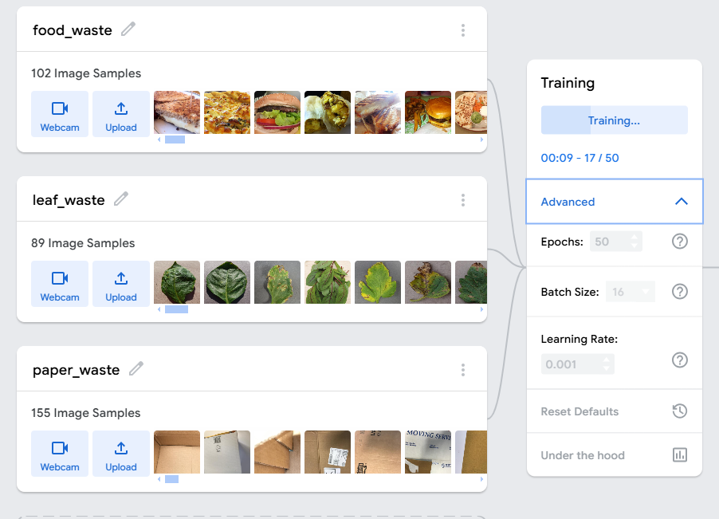

After started,

1. **Testing the Model**:
   * After training, test the model by uploading or using the webcam to capture new images of each waste type.

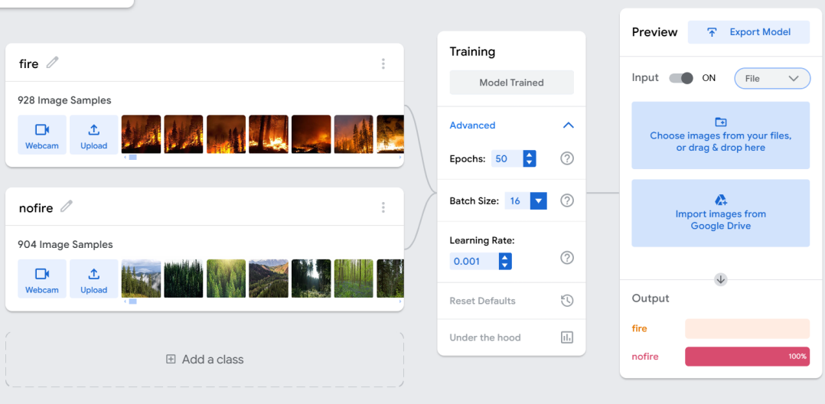

* + The model will display predictions, showing the likelihood that an image belongs to each category.

Food waste

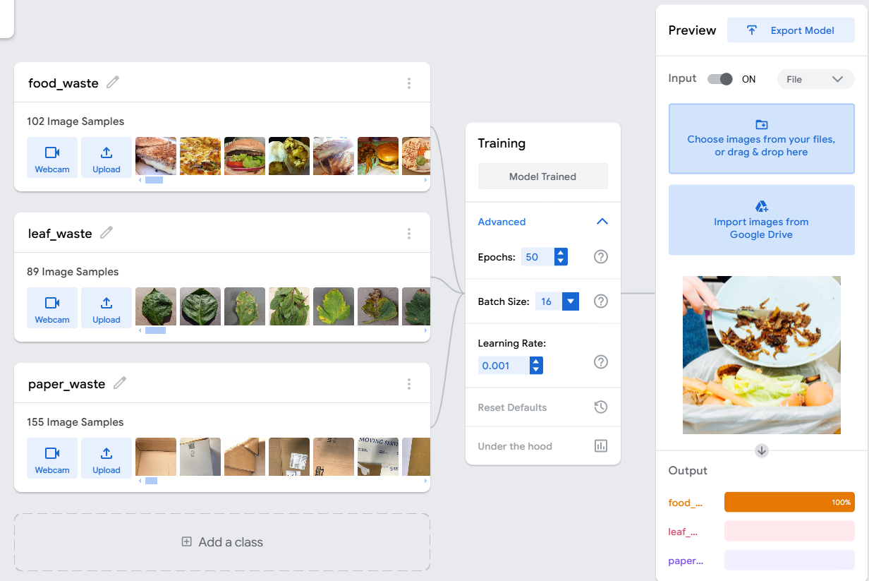

Leaf waste

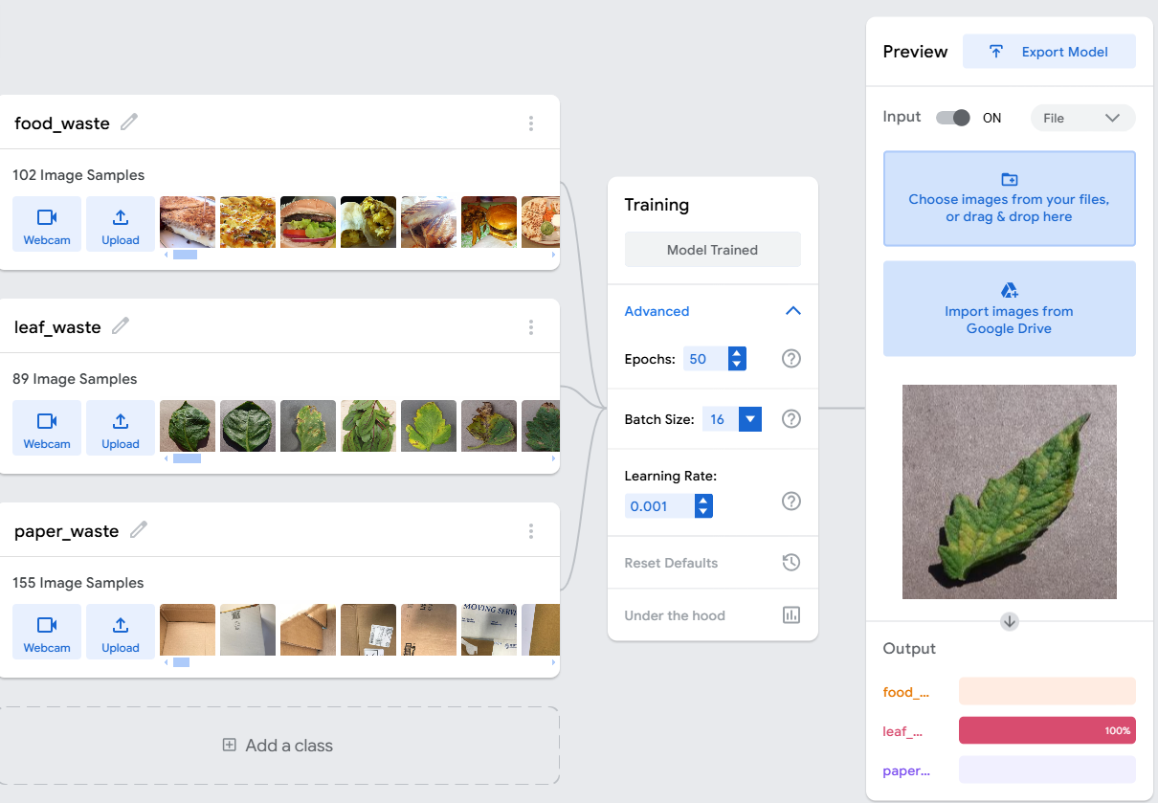

Paper waste :

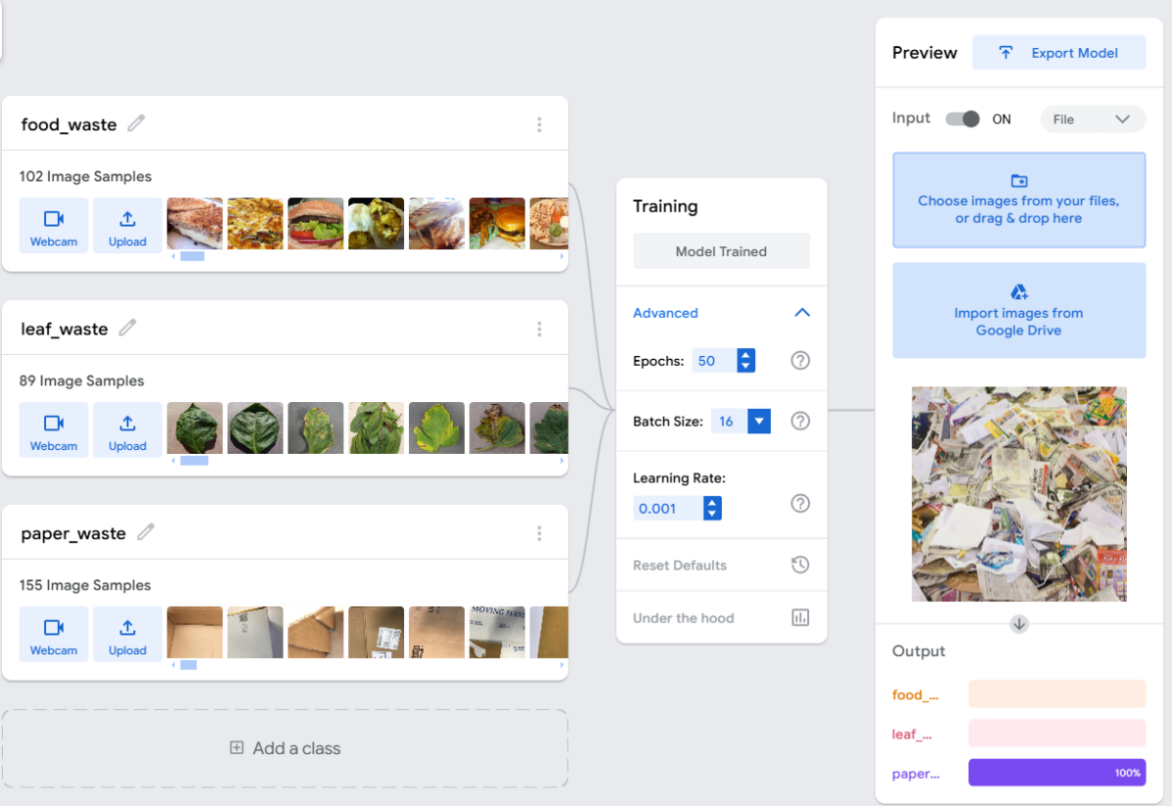

**Export Model**

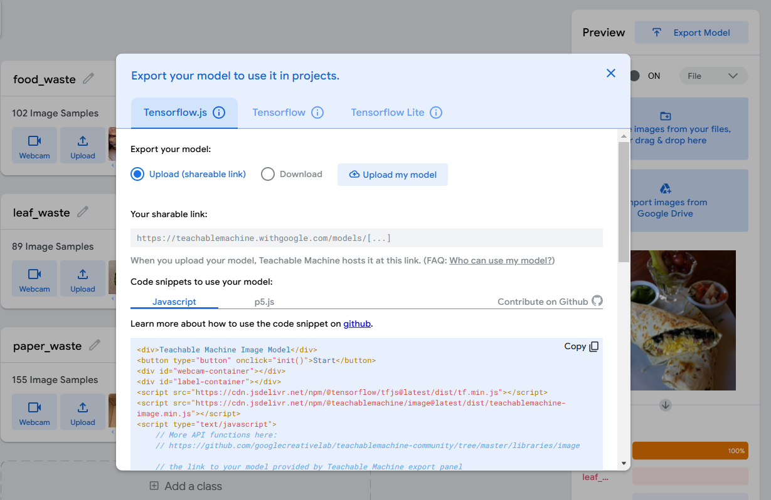

We can use in different in app development.